TRYHACKME LAB WRITEUP
Linux Logging for SOC
Platform | TryHackMe
Room | Linux Logging for SOC
Room URL | https://tryhackme.com/room/linuxloggingforsoc
Date completed | 01/11/2026

1. Objective
The objective of this room is to understand how Linux logging supports Security Operations Centre (SOC) investigations. The room introduces Linux log sources, ways to search and filter log entries, and runtime auditing with auditd.

2. Learning outcomes
- Identify common Linux log locations and understand what information they contain.
- Use command-line tools to read, search, and filter log files.
- Recognize authentication-related events such as login attempts and session activity.
- Understand why ordinary system logs may not record every runtime action.
- Explain how auditd and audit rules provide additional visibility into system activity.
- Relate Linux log analysis to threat detection and incident investigation in a SOC.

3. Key concepts

3.1 Linux log locations
Linux systems commonly store text-based logs under /var/log. The exact files available depend on the Linux distribution and its logging configuration. Examples include:
Log path | Typical content | SOC investigation use
/var/log/auth.log | Authentication and authorization messages on Debian/Ubuntu systems. | Review SSH logins, failed authentication, sessions, and sudo activity.
/var/log/secure | Authentication messages on many RHEL-based systems. | Investigate access and authentication activity.
/var/log/syslog | General system and service messages on Debian/Ubuntu systems. | Review service activity, warnings, and system events.
/var/log/messages | General system messages on many RHEL-based systems. | Review system and service events.
/var/log/kern.log | Kernel-related messages where configured. | Investigate kernel and driver-related events.
/var/log/audit/audit.log | Linux Audit subsystem records when auditd is enabled. | Investigate audited commands, system calls, and file activity.

3.2 Reading and searching logs
A SOC analyst often filters log files instead of reading every line. Common commands include:
- ls -lah /var/log — List log files and their details.
- less /var/log/auth.log — Read a log file page by page (on systems where this file exists).
- tail -n 50 /var/log/auth.log — Display the most recent 50 lines.
- tail -f /var/log/auth.log — Follow new log entries as they are written.
- grep -i 'failed' /var/log/auth.log — Search for lines containing the word 'failed', ignoring case.
- grep -E 'Accepted|Failed' /var/log/auth.log — Filter common SSH authentication result messages.
Note: Log paths vary by distribution. If a listed file does not exist, identify the distribution and check its configured logging service and available files.

3.3 Authentication logs
Authentication logs can record successful and failed login attempts, SSH activity, session creation and closure, and privilege-related activity such as sudo. During an investigation, an analyst should correlate timestamps, usernames, source IP addresses where recorded, and related events. A single failed login does not prove an attack; repeated failures or unusual successful logins may need further investigation.

3.4 Runtime monitoring and auditd
Runtime activity includes actions performed while a system is operating, such as executing a process or accessing a file. Standard system logs may not capture every such action. The Linux Audit subsystem can record selected activity according to configured audit rules. The auditd service manages audit records, commonly stored in /var/log/audit/audit.log.
- sudo systemctl status auditd — Check the audit daemon status.
- sudo ausearch -m EXECVE -ts recent — Search recent command-execution audit records, if such events are being audited.
- sudo ausearch -i -ts recent — Display recent audit records with interpreted values.

4. Practical work and observations
Complete this section using observations from your own TryHackMe session. Enter the commands you actually ran and the results shown by the room. Do not guess answers or copy values from another user's machine.

Task / section 1 – Introduction
Main idea learned: [Fill in from your lab]
Important observation: [Fill in from your lab]

Task / section 2 – Linux log files
Log file inspected: [Fill in from your lab]
Command used: [Fill in from your lab]
What the output showed: [Fill in from your lab]

Task / section 3 – Authentication activity
Authentication event investigated: [Fill in from your lab]
Relevant username / source / timestamp (if shown): [Fill in from your lab]
What the event may indicate: [Fill in from your lab]

Task / section 4 – Runtime monitoring / auditd
Audit rule or event examined: [Fill in from your lab]
Command used: [Fill in from your lab]
Important fields observed: [Fill in from your lab]
What the record indicates: [Fill in from your lab]

5. Screenshots / evidence
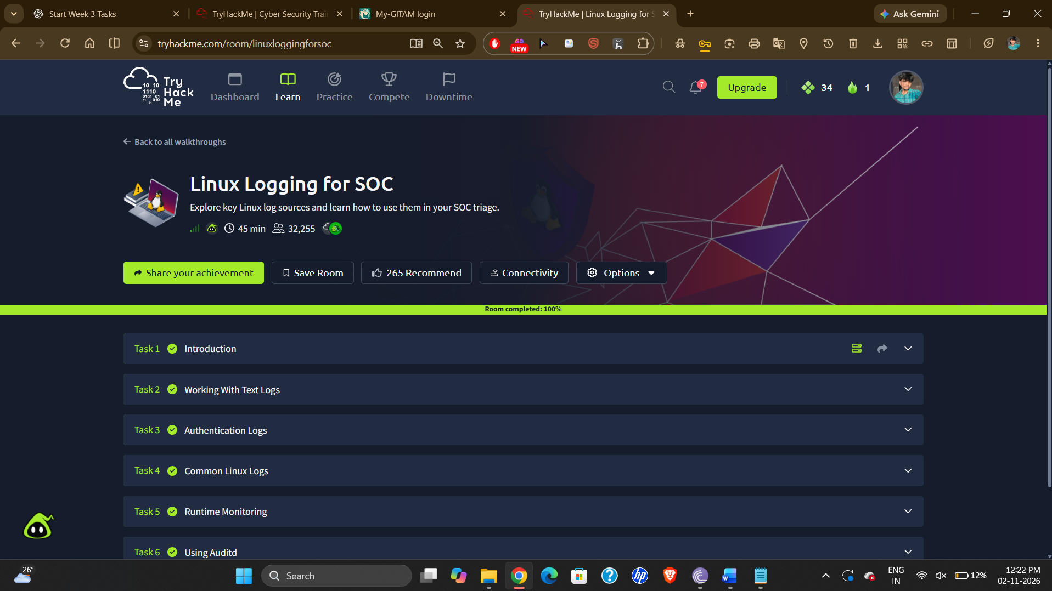

6. SOC analyst relevance
- Authentication logs help identify suspicious login patterns and possible brute-force attempts.
- System logs provide context about service failures, system changes, and unusual host activity.
- Audit records can provide evidence about commands and actions performed on a Linux host.
- Correlating timestamps, users, processes, and source addresses helps build an incident timeline.
- Logs should be interpreted in context; one event alone may not establish malicious activity.

7. Key takeaways
- Linux log files are commonly located in /var/log, but exact paths vary by distribution.
- Commands such as less, tail, and grep help analysts inspect and filter logs.
- Authentication logs are useful for investigating SSH, login, session, and sudo activity.
- auditd records selected system activity according to configured audit rules.
- Good log analysis requires correlating events and validating whether activity is expected.

8. Conclusion
This room builds foundational Linux log-analysis skills for SOC work. By learning where Linux stores logs, how to search authentication and system events, and how auditd records selected runtime activity, an analyst can gather useful evidence during endpoint investigations. These skills support alert triage, threat hunting, and incident response.

